Atmosphere Notes

**Layers of the Atmosphere**

_______________________

* first layer above the surface
* contains half of the Earth's atmosphere
* Weather occurs in this layer
* Heated by the ground
* Temperature decreases as you move upward

_______________________

* Aircrafts fly here because it is very stable.
* Ozone layer is located here which absorbs energy from the Sun as its heat source
* Temperature increases as you move upward

_______________________

* Meteors or rock fragments burn up here
* Layer is heated from below by the stratosphere
* Temperature decreases as you move upward

_______________________

* Auroras occur here
* Space shuttle orbits here
* Layer is heated by radiation from the sun
* Temperature increases as you move upward

_______________________

* Where the atmosphere merges into space
* Extremely thin
* This is the upper limit of our atmosphere.

**Absorption & Reflection of Solar Energy**

* About _________ of solar energy is reflected by the earth’s surface
* About _________ of solar energy is reflected by clouds and the earth’s atmosphere
* About _________ of solar energy is absorbed by clouds and the atmosphere
* About _________ of solar energy is absorbed by the earth’s surface

**Transfer of Solar Energy**

* Conduction –
* Convection –
* Radiation –

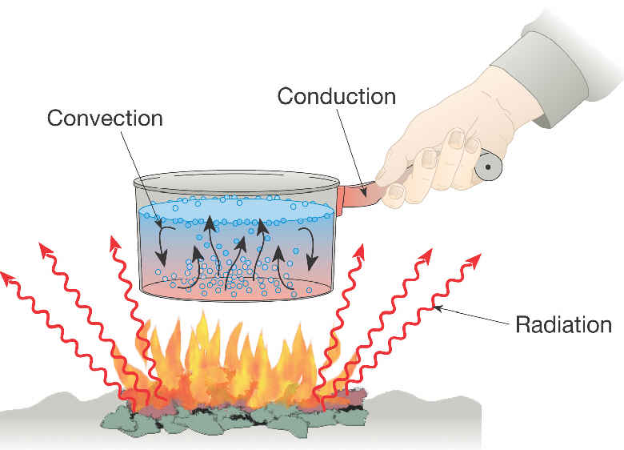

**Heating of the Earth**

Higher latitudes receive more slanting, indirect rays and more diffuse energy

At lower latitudes, the sun’s rays are more direct and concentrated

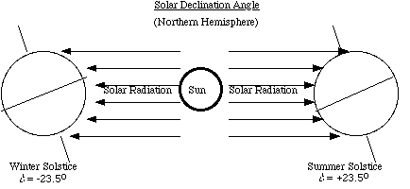

**Temperature & Air Pressure**

* Uneven heating of Earth creates different air pressures (highs and lows).
* _____________________ – Created by the number of air molecules moving and bouncing off an object.
  + _________________- used to measure air pressure

Examples:

* Warm air = more active air molecules = low air pressure
  + Ex: equator
* Cool air = less active air molecules = high air pressure
  + Ex: poles

**Elevation & Air Pressure**

* As elevation increases, pressure decreases and vice versa

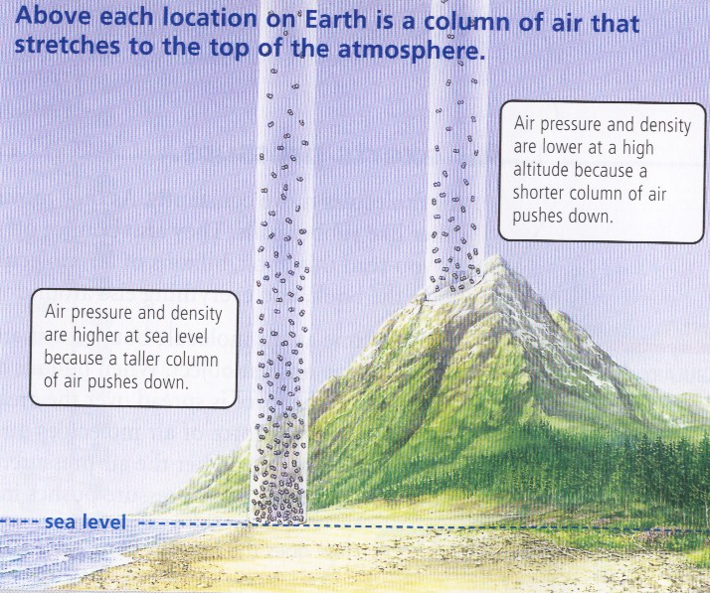

**Air Pressure & Moisture**

Low air pressure usually means warm humid weather (ex: equator). Why?

High air pressure usually means cooler drier weather. Why?

**Differences in Temperature & Air Pressure**

**\*\*\*Remember: uneven heating of the Earth creates differences in air pressure\*\*\***

What do the differences in temperature and air pressure create?

How do they create wind?

**Creation of Wind**

* Air moves from greater concentration to lesser concentration

Warm air rises Cooler air sinks

High Pressure

Wind moves across surface

Low Pressure

**Sea and Land Breeze Convection Currents**

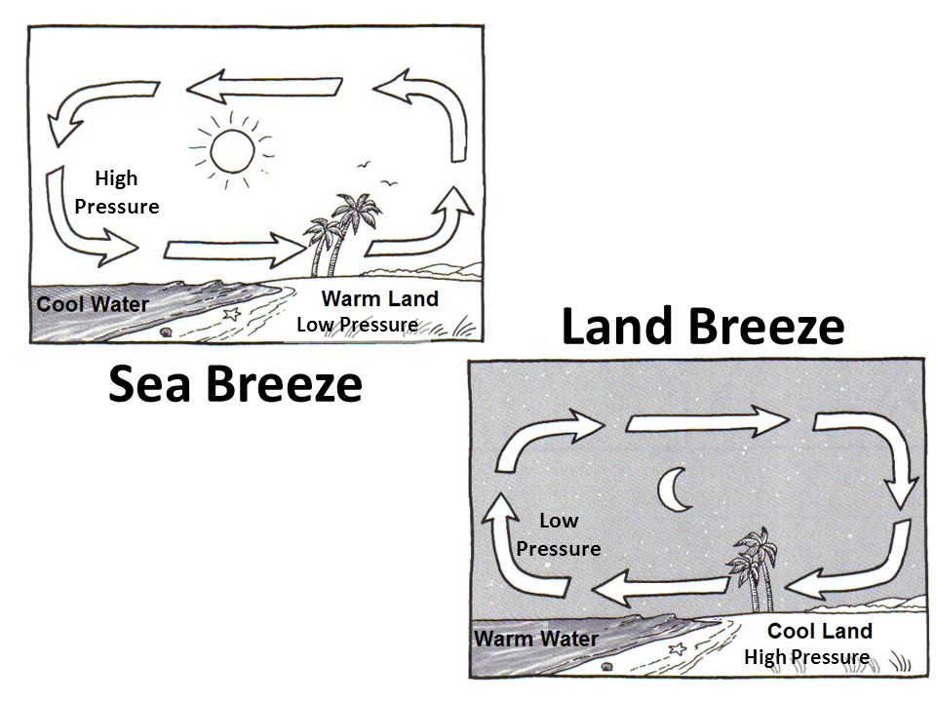

**Global Winds**

* The uneven heating of the earth creating differences in air pressure creates ______________ _______.
* At the poles: indirect solar energy; cold temps; high pressure
  + - air sinks and moves towards the equator.
* At the equator: direct solar energy; warm temps; low pressure
  + - air rises and moves towards the poles.
* The circular movement is called a ___________________________.

**Complex Movement of Global Winds**

* The influence of the Earth’s rotation on the movement of air and water is called the Coriolis Effect.
  + - The Coriolis Effect cause global winds to turn:
      * Northern Hemisphere = ________________________
      * Southern Hemisphere = ________________________